Observations on Madrid in detail:-

1. **Majority of the population resides in the central part of the city districts.**

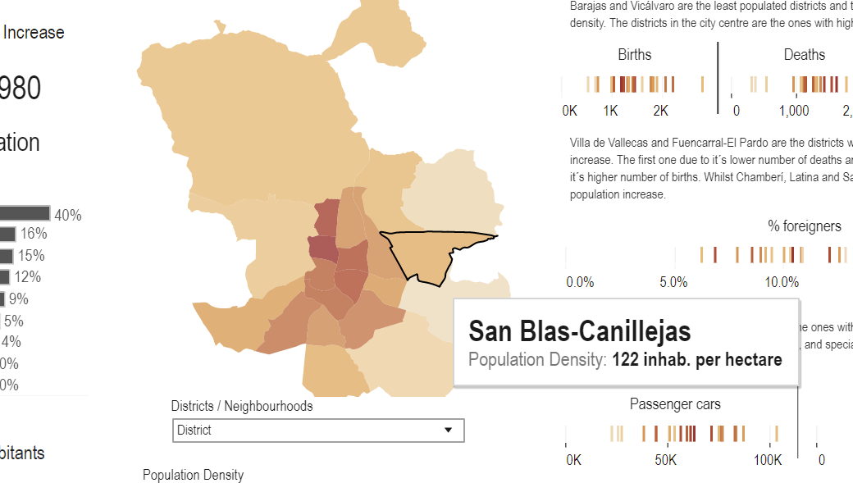

When I selected District from the dropdown in the dashboard I could see majority of the Madrid population residing in the Central part of the city and the other parts have less population.

I clicked on Districts like Tetuan and found it had 298 inhab per hec,also Chameri has 322 inhab per hec .

2. **There is a correlation between the housing price and the number of cars in an area. A place in the city where the housing cost is more has a higher number of cars per 100 people.**

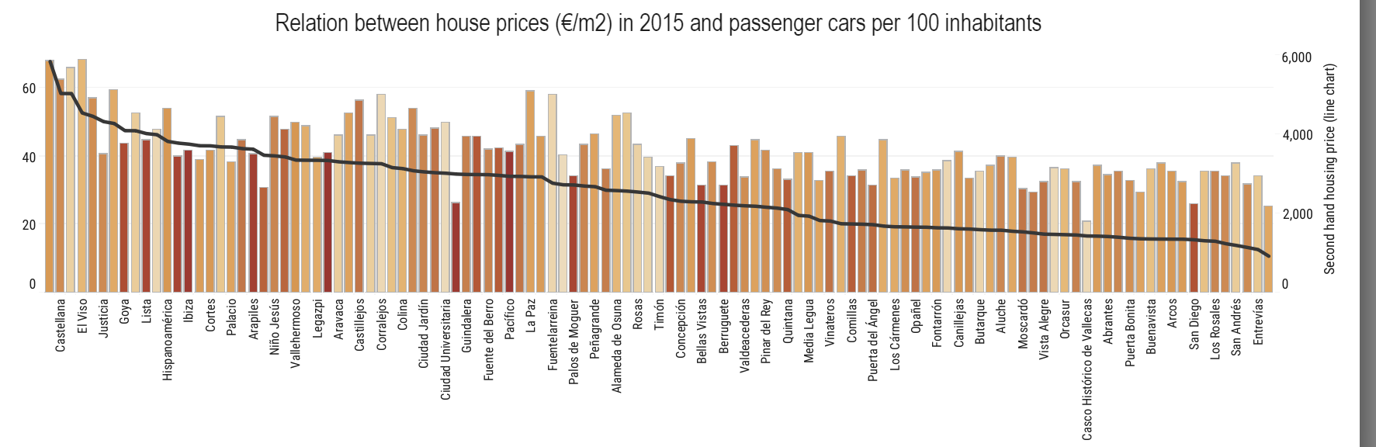

When I clicked on the graph depicting the relation between house prices and passenger cars. I found out that the number of passenger cars where more where the house prices were more. This depicts the standard of living of these people are better than people of other regions as they could afford to live in higher price houses and drive cars.

**3. The higher percentage number of foreigners live in the more populated areas of the city.**

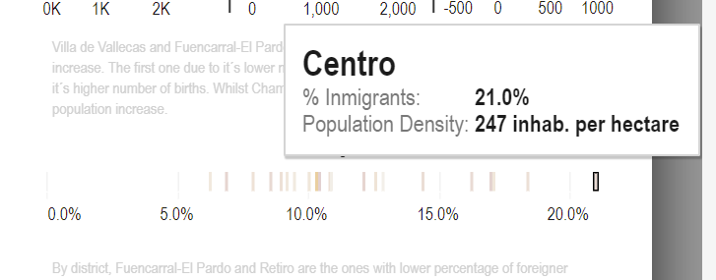

When I clicked on the visualization, depicting the percentage of immigrants, it could be found out the regions of higher density of population consisted of immigrants. This gives the insights immigrants live in areas of high population density because there will be more work opportunities in these regions leading to more people living there.